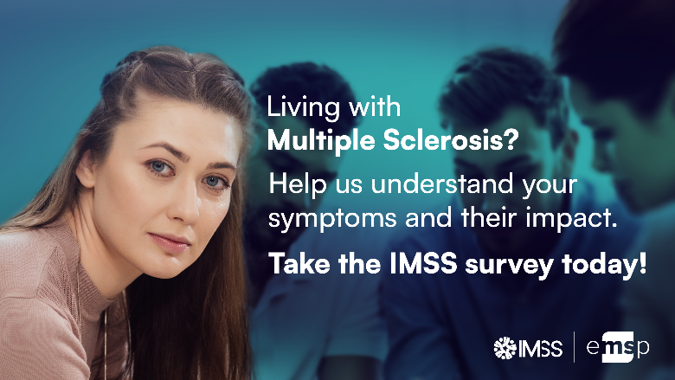

*[To insert 16-9 social media banner of your country instead of the English version above]*

Impact of Multiple Sclerosis Symptoms (IMSS) Survey!

Assessing the impact of MS symptoms on the quality of life of people with MS to provide personalised care and support:

*Tell us how MS is impacting your life?*

**Background and rationale**

There is currently no prioritization on how MS symptoms manifest among patients in Europe nor is the management of those symptoms prioritized and equally supported in Europe. Through the [MS Barometer in 2020](https://msbarometer.eu/2020), the European Multiple Sclerosis Platform (EMSP) has highlighted the current gaps that health and social systems across Europe have in providing quality **symptomatic care** to people with MS. Consequently, there is lower availability and lower reimbursement of symptomatic treatments, including medication, rehabilitation in all its forms, while there is little attention to lifestyle changes.

For this reason, **[Insert name of MS society] alongside the European Multiple Sclerosis Platform and 24 other national MS Societies from 23 countries** are leading on this research project titled **Impact of Multiple Sclerosis Symptoms survey (Acronym is IMSS in English)** to understand:

* The symptoms of MS, their prevalence and severity
* How MS symptoms are being managed and their impact on your life

Documenting MS symptoms, their severity and how they affect the quality of life and disability is crucial at this stage and cannot be delayed. The aim is to further understand MS symptoms and what the best care that people living with MS are adopting. It will also serve as a catalytic agent for advocacy on MS symptom management to push for the development of personalized and timely approaches of management and care.

### How and when will IMSS take place?

The survey will be a **confidential, anonymous, and voluntary** online questionnaire, in all national languages of participating countries. It is estimated that the survey will take 20 to 30 minutes. Your name, identity, and IP address will not be requested or saved.

The survey will include 4 sections after the background and consenting:

* *Sociodemographic information and disease history* including age, gender, ethnicity, employment, education, country, onset of symptoms and diagnosis, caregiver presence, living arrangements, presence of comorbidities, use of disease modifying therapies, as well as mobility and quality of life
* *MS symptoms*, their presence and severity
* *Treatment and care methods* adopted by you
* *Satisfaction*with how you are currently managing their symptoms

The survey is launched on **May 10 2023** and will be open for *3 months*.

### Who can participate?

Any person diagnosed with MS in the participating countries can take part in this survey after providing their consent. People with MS under the age of 18 can still participate but will require the consent of their caregivers/parents as well.

The aim of IMSS is to reach 20,000 people with MS in all of Europe.

The survey will be disseminated to MS communities in [Insert your country] but also in 22 other *European countries*, including Belgium, Croatia, Czech Republic, Denmark, France, Germany, Greece, Hungary, Iceland, Ireland, Italy, Latvia, Lithuania, Luxembourg, Netherlands, Norway, Poland, Portugal, Romania, Serbia, Slovenia, Spain, and Switzerland.

**Would you like to take the survey?** Please find it here: <http://impactofms.com/>

**Please share it with people with MS who might be interested as well!**